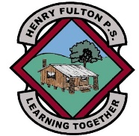
Henry Fulton Public School
Google Classroom Codes - 2021

Instructions on how to access Google Classrooms can be found on the school website. Your child will need their DET login details to access this online learning platform. If you do not have your child’s details, please email the school and we will send them to you. henryfulto-p.school@det.nsw.edu.au

KA - jzrpjyd
KC - ia4fw3t
1C - kkbmzg2
1F - adzcue4
1U - otww6p6
2A - btfdpdm
2VC - ji5saiv
3M - s6yz2ng
3/4G - lapv6jw
4/5J - k6cd4jx
5L - 7pg4b5t
5/6C - lexmq67
6H - m4cmyt6
If you have any difficulties using or accessing Google Classrooms you can email or call the school. The school email address is henryfulto-p.school@det.nsw.edu.au

